xUnit Patterns (<http://xunitpatterns.com/>)

Legacy code is “code that have no test”

Unit Test Antipatterns

**Test First or Test-Drivent Development (TDD)** practice pattern for writing Unit Test code before write production code.

Traditional Development

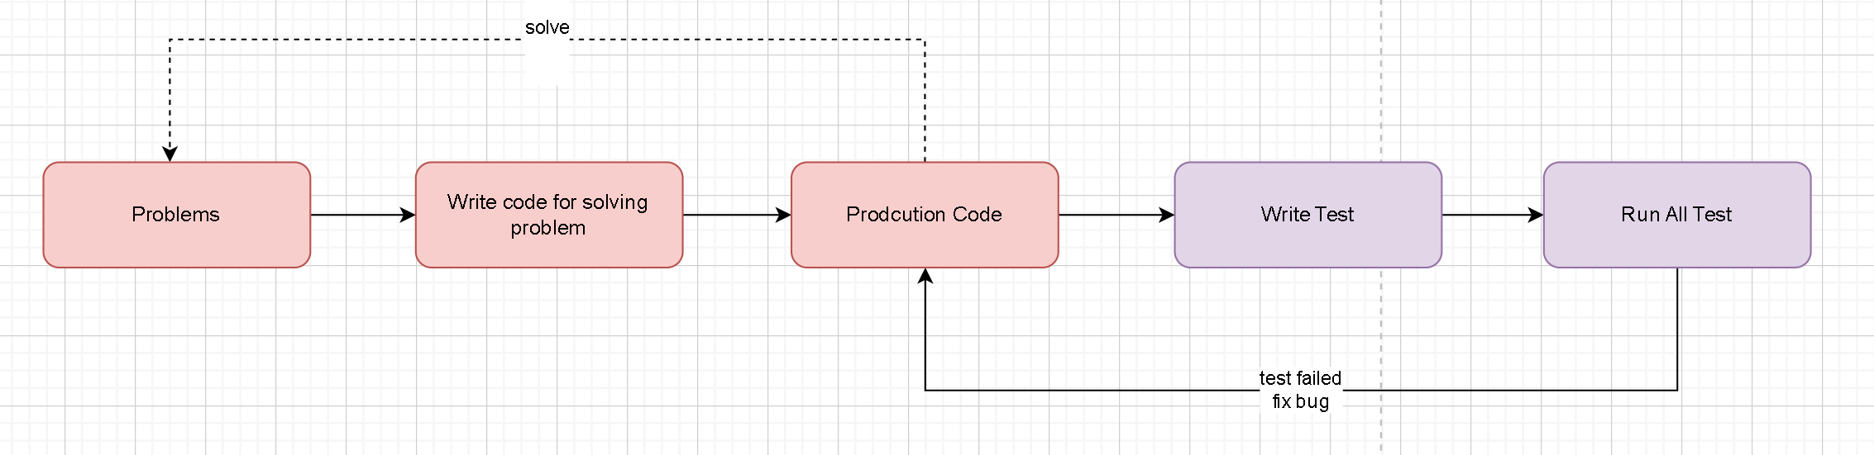

Test Driven Development

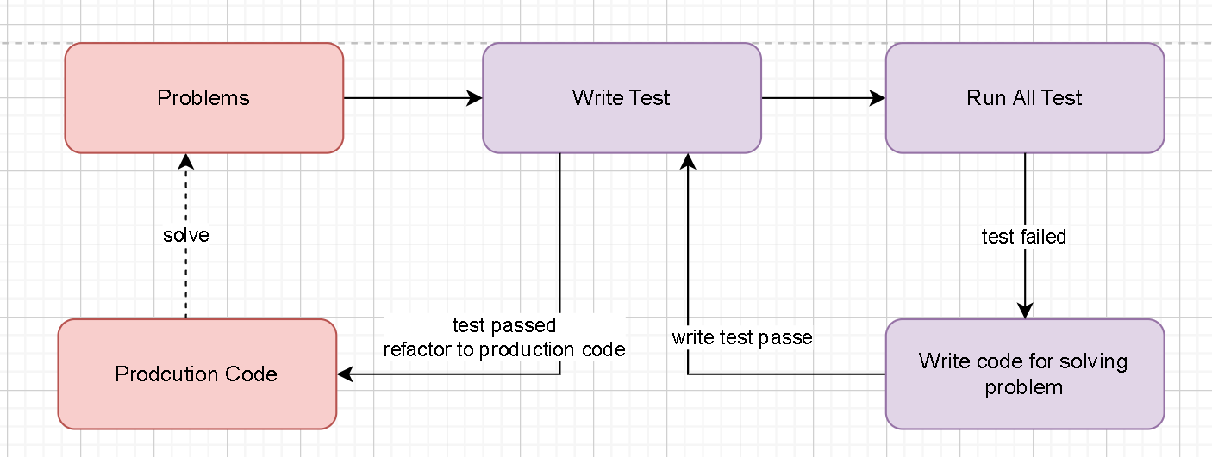

1 Write a failing test to prove code or functionality is missing from the end product.

2 Make the test pass by writing production code that meets the expectations of your test.

3 Refactor your code.

References

